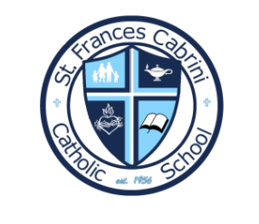
St. Frances Cabrini Catholic School
1st & 2nd School Supply List

- Pencils (2 packs, if mechanical, please send plenty of lead)
- 3 boxes of facial tissues (or 4 boxes of smaller size)
- 5 reams of copy paper
- 6 rolls of paper towels
- Water bottle WITH LID, NO LEAK to be kept in classroom *VERY IMPORTANT- metal damages floors, and glass is unsafe
- 1 bottle of dish soap, no size or brand preferred
- 1 package of sponges
- 3 rolls of disinfectant wipes
- 1 pack of fine tip markers
- 3-inch binder to house graded work
- 1 box of gallon storage bags
- 1 box of sandwich sized storage bags
- 1 pack paper plates
- 3 bottles of hand soap
- Personal Headphones for Chromebooks (to be left at school)
- Appropriate Mass uniform

