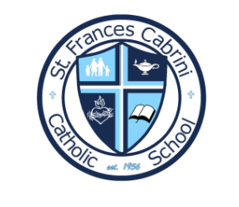
St. Frances Cabrini Catholic School
3rd & 4th School Supply List

- 2 Reams of Copy Paper
- 2 Containers of Disinfecting Wipes
- 2 Boxes of facial tissues
- Appropriate Mass Uniform
- Reusable Plastic Water Bottle -VERY IMPORTANT- metal damages floors, and glass is unsafe
- Pencils (sharpened preferred)
- Color pencils, markers, crayons, or highlighters (your choice for notetaking)
- Personal Headphones for Chromebooks (to be left at school)
- *Scissors
- *Glue

* Not required as I have class sets of these items.

