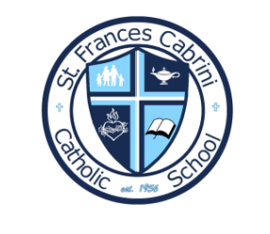
St. Frances Cabrini Catholic School
Kindergarten School Supply List

- 1 package of construction paper
- 4 reams of copy paper (this includes one ream for specials classes)
- 2 packages of paper plates (cheapest is fine)
- Personal Headphones for Chromebooks (to be left at school)
- Appropriate Mass uniform
- Reusable plastic water bottle ****VERY IMPORTANT - metal damages floors and glass is unsafe
- 1 composition book (journal half page ruled)
- 1 washable markers, box(es)
- 1 Package Filler Paper Wide Ruled notebook paper
- 2 boxes of #2 pencils
- 1 pair of scissors
- 3 pocket folders
- 2 Primary composition notebooks (k-5)
- 1 pair of headphones
- 6 glue sticks
- 1 pink eraser
- 1 school supply box (plastic) or zipper pouch
- 3 boxes of facial tissue
- Appropriate Mass Uniform

