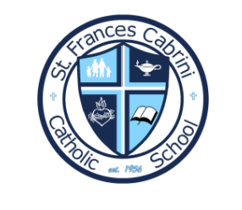
St. Frances Cabrini Catholic School
3rd & 4th School Supply List

- 2 Bags of 8 count paper towels
- 2 Boxes Gallon sized Ziplock baggies
- 2 Boxes sandwich sized Ziplock baggies
- 2 Boxes snack sized baggies
- 1 Box 30-gallon trash bags
- 1 Box 13-gallon trash bags
- 2 Boxes Kleenex
- 2 Package baby wipes
- 1 Box of plastic forks
- 1 Box plastic spoons
- 1 Package paper/form plates
- 2 Bottles hand soap
- 1 Bottle hand sanitizer
- 2 Folders (Favorite character of Design)
- 2 Large purple glue sticks
- 2 Small purple glue sticks
- 2 Bottles Elmers glue
- 1 Pencil box
- 1 Box 8 count Jumbo crayons (Pre-K 3)
- 2 Boxes 8 count crayons (Pre-k 4/5)
- 2 Fat Pencils (If you can find them)
- 1 Crib Sheet
- 1 Small Pillow
- 1 Blanket
- 2 Plastic drinking water bottles
- Large Sized Backpacks, PLEASE!

